Vlisco and the construction of African identity

Author: Jos Arts

Abstract:
Many West and Central African women consider wax prints as authentically African, as part of their African identity, and wrapped and/or sewn wax print ensembles can be found from Senegal to the Democratic Republic of the Congo and are very often seen as a kind of national dress. However, a large percentage of the wax prints sold in Africa are designed and produced in Europe and Asia, among these the most prestigious brand of all, Vlisco, that has been produced in the Netherlands since the 19th century.

This paper investigates, from a historical and semiotic perspective, how a product with Asian roots, designed and produced in Europe, could attain the status of national dress in many West and Central African countries, and is even considered by many as part of African cultural heritage. First I will describe how the wax print travelled from Indonesia to the Netherlands, and then to West and Central Africa. Subsequently I will examine how (female) consumers Africanised the fabric and have made it part of their African identity, a practice that still continues today.

Next to literary sources for my research I made use of the Vlisco archive and conducted extensive interviews with key figures of the Vlisco organisation and with trades women, shopkeepers, tailors, stylists and consumers in Kinshasa, Democratic Republic of the Congo.

Keywords:
Wax prints, West and Central Africa, the Netherlands, global/local, identity, cultural heritage

A letter from Java
In the summer of 1852, Pieter Fentener van Vlissingen, Jr, director of the Helmond cotton printing mill P.F. van Vlissingen & Co., received a letter from his Uncle Frits, who for years had been living in what then was still called the Dutch East Indies. He had discovered a fabric in the southern part of Java that might be of interest to his nephew, Frits wrote in his letter, and he enclosed two small swatches as samples (Fig.1).

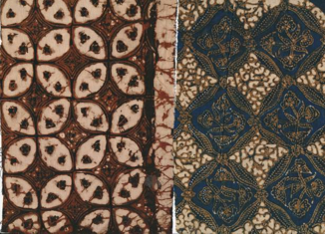
Figure 1 Two fabric samples from the Dutch East Indies (now Indonesia), 1852

Pieter had never seen anything like it, but as a cotton printer he was impressed by the quality of the fabric and the craftsmanship it demonstrated. This is batik tulis, Frits explained, which is printed entirely by hand according to a process that was invented in India on the coast of Coromandel and then brought to Java by traders during the twelfth century. Over the centuries the process was refined, to become the delicate art form it is today.
The process was highly labour-intensive. A printer took weeks, sometimes even months, to print a beautiful sarong, and for most Javanese that was prohibitively expensive. That was exactly why Frits sent his nephew those samples. If Pieter could print these kinds of fabrics in an inexpensive way, said Frits, a vast market would open up to him. Pieter became intrigued, and he was determined to do something with this printing technique. (Krantz 1989; Jacobs and Maas 1996; Frans van Rood, former head of Vlisco’s Development and Design Department, interview with author, Geldrop, 7 September 2010). What he didn’t realise was that in doing so he was putting his company on a brand new track, a track that would make it a leading name in fashion in West and Central Africa over a hundred and fifty years later.

The birth of an industry
P.F. van Vlissingen & Co. was not the only Dutch cotton printer to throw itself onto the imitation batik market. Other well-known names were the Haarlemsche Katoenmaatschappij and the Ankersmit cotton printers of Deventer (Heringa 1989; Krantz 1989; Jacobs and Maas 1996). Things were going well for Van Vlissingen & Co., and the factory was constantly undergoing expansion. The Dutch East Indies was its most important market during those years, but due to a number of reasons and starting in about 1870 times became difficult. The company had to fight to survive, and tried to reduce the dependence on the Dutch East Indies by searching for new export markets. After years of travel and exploratory investigation, that market was eventually found in West and Central Africa.

Fabrics to suit the African taste
It wasn’t that odd for Fentener van Vlissingen to end up in Africa, since the Dutch had already been involved in the African textile trade for centuries. It all began in the seventeenth century when the Dutch East India Company introduced cotton textiles from India. The fabric they traded was chintz: it was light and colourful, the patterns were beautiful and it was colourfast as well as extremely supple − quite different from the boring colours of the heavy linen fabrics that had been worn up until then. These Indian textiles caught on quickly in both Africa and Europe. Two enterprising Dutch merchants, Jacob ter Gou and Hendrick Popta, saw big possibilities in the new fabrics, and in 1678 they started the first European cotton printing mill in Amersfoort. By around 1750 there were more than a hundred throughout the Netherlands. Cotton printing soon spread from the Netherlands to the surrounding countries, mainly England and France (Rodenburg 1967). In order to compete with the producers of Indian textiles, the European textile manufacturers had to adapt their product to suit the African taste. First they switched to lightweight cotton, but soon they went one step further: they geared the colours and patterns to suit not only the various countries but also the regions, which all had their own tastes and preferences. Some manufacturers even made special trips to Africa and purchased locally produced fabrics so they could copy the patterns and colours. Eventually the European cotton printers managed to push the Indian textiles from the market (Indian textiles were not mechanically produced and thus were more expensive), and over the course of the nineteenth century they acquired a strong position in the West African textile market (Nielsen 1979; Steiner 1985).

Real Dutch Wax
At first the patterns of the wax prints for Africa were based entirely on Javanese motifs. The Haarlemsche Katoenmaatschappij was the first cotton printing mill to create a collection more in line with the African market, and it was also the first to develop a roll printer by which the hot resin could be applied to both sides of the cloth. The company served as an example for other Dutch printers, such as Van Vlissingen and Ankersmit, who began working with virtually identical machines a few years later.
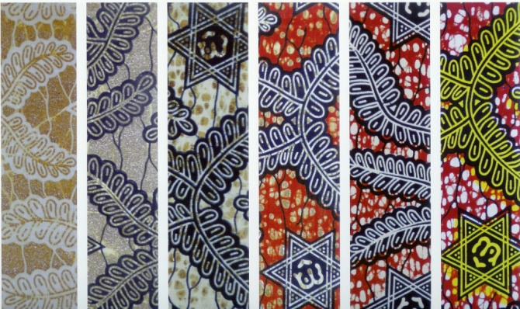
Figure 2 Successive stages in production process of wax prints
The process consisted of the following steps: the machines would first apply the resin mixture to both sides of the cloth by means of engraved rollers. Then the cloth would be dyed in a foundation colour. Most of the resin would then be removed, leaving only small balls of resin attached to a number of carefully chosen spots. A second colour would then be printed on the cloth by hand using wooden printing blocks. When all the resin was finally removed, the result would be the pattern made so lively by its irregularities that would become characteristic of the African wax print: perfect imperfection. (Fig. 2, Joop Martens, project & knowledge manager at Vlisco’s R&D Innovation Department, interview with author, 19 April 2011). This unique process, and the special designs geared to the African taste brought the Haarlemsche Katoenmaatschappij much success and Real Dutch Wax became the African standard.

Never waste a good crisis
The stock market crash of 1929 and the Depression that followed caused many Dutch cotton printers to go bankrupt, and by the mid-thirties only Ankersmit and Van Vlissingen remained. Ankersmit, however, had acquired a much better position in West Africa, while Van Vlissingen was having the greatest difficulty keeping its head above water. Director Jan Fentener van Vlissingen refused to take this lying down and was determined to pull his company through the crisis. In 1932, in order to become better acquainted with the African market, he sent commercial director Tobie Hoogenboom on a journey. Hoogenboom quickly discovered that Van Vlissingen’s somewhat sombre colours were not very popular among the West Africans, who had a greater preference for the brighter Ankersmit colours. Van Vlissingen immediately modified the production process and the colours, and when Jan Fentener van Vlissingen himself visited Africa for the first time in 1934 he noticed that the company’s market position had improved substantially with respect to Ankersmit.
After his first trip to Africa, Jan Fentener van Vlissingen became more and more interested in the continent, its culture and its inhabitants. He may even have been one of the first Westerners to take the African consumer seriously and to recognise that Africans also have an eye for quality and are not satisfied with inferior fabrics and patterns. And perhaps that is why he attached so much value to the designing of the company’s own patterns, patterns that were actually based on visits to Africa and therefore resonated with the tastes of the African consumer. But Van Vlissingen was also a businessman, of course − an entrepreneur who saw his company suddenly doing much better in the market after the introduction of a few innovations. It was clear to him that that’s where the future lay, in those innovations, and when production almost came to a halt during the war years he worked hard on preparations for an autonomous research department with a laboratory and pilot plant. That research department was opened in 1947 and would make an important contribution to Van Vlissingen’s success in the years to come. Techniques were developed there to speed up and improve the working process. A large number of new, highly saturated colours were also created, full colours that contained a great deal of pigment, so that even in the bright African sun they remained strong and did not fade. Colours that very much appealed to local taste.

African cultural heritage
Between 1946 and 1960 the demand for wax prints in West and Central Africa skyrocketed. This was partly attributable to the growing purchasing power in many African countries. The growing power of the various independence movements also played a role. For almost a century, missionaries and colonisers had suppressed traditional African clothing and tried to replace it with Western dress. The independence movements increased African self-awareness, and traditional African clothing became something to be proud of once again. It became a symbol of anti-colonialism, and some even elevated it to the status of new national costume (Bender 1989, p. 165; Rabine 2002, p. 75; Gott 2010). Surprisingly enough, the renewed interest in traditional clothing did not lead to a decline in textiles imported from Europe. On the contrary, the imports only increased. While Van Vlissingen produced only 1 million yards of wax prints in 1946, by 1960 that number had grown to at least 34 million (Jacobs and Maas 1996, p. 83).
The inescapable question, then, is how to explain these contradictory tendencies? How was it possible to achieve such impressive sales with Real Dutch Wax, a product entirely designed and manufactured in the Netherlands, at a time when so much attention was being paid to African identity? The fact that wax prints were European must have added to their popularity, and hence made them prestigious for many people, but the big mystery is that at the same time wax prints were regarded as native and authentically African, as part of African cultural heritage.

Fashion as cultural improvisation
In his article ‘The “African Print” Hoax’, Tunde Akinwumi inveighs bitterly against the manufacturers of wax prints, also called African prints, because (he says) they deceive the African consumer with patterns that are a mixture of Javanese, Indian, Chinese, Arabic and European artistic traditions, but have nothing to do with the traditional African aesthetic. So Akinwumi calls for a new aesthetic for Africa, for patterns that are based on indigenous African textile art such as kente, adire, aso-oke and bogolanfini (Akinwumi 2008). What he neglects to mention, however, is one essential characteristic of fashion: that it’s constantly changing, that it’s a response to an ever-changing world, to changing points of view, to the meeting of different cultures. In the words of Victoria L. Rovine, ‘Dress is mobile and malleable in both form and meaning – an ideal medium for exploring changing identities at the intersection of cultures’ (Rovine 2010, p. 89). Because clothing styles are always changing, says Rovine, they can bridge cultural and chronological borders, and those changes can be inspired by a vast array of sources: by fashion magazines, dressmaker’s studios, films and museums, by designers of haute couture or by the creativity of consumers, who combine articles of clothing on their own to come up with new, personal styles. That’s exactly what happened when the first Europeans settled on the coast of West and Central Africa. Western garments such as bowlers and top hats were quickly adapted and incorporated into the local fashion, thereby acquiring a special African significance. It’s a significance that still lives on, while the hats themselves went out of fashion long ago in the Western world (Fig. 3, Rovine 2010, p. 90).
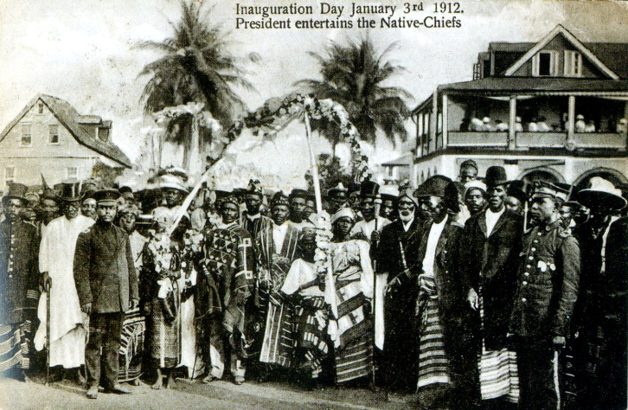
Figure 3 Western garments incorporated into local fashion, Liberia 1912
The Kalabari, a population group living in southern Nigeria, long ago adopted a plaid fabric from Madras in India, made a few changes and, from that moment on, regarded it as their own authentic native costume (Luttmann 2005, p. 18). A similar tendency can be seen in the use of second-hand clothing in Africa. What makes it attractive is not only the price but also the fact that it’s different, ‘exclusive’: it’s not what everyone else is wearing, which makes it an important vehicle for letting people know who you are or who you want to be. It does mean that you have to make a careful choice from an enormous range of items, that you have to have a strong sense of what’s appropriate and when, and that sometimes you have to adjust the garments yourself. The fact that second-hand clothing is worn in many African countries does not make it a slavish imitation of Western clothing styles, according to Karen Tranberg Hansen, but a cultural improvisation in which new value and new meaning are imparted to the clothing, tailored to one’s own situation (Hansen 2010). The Malian-Senegalese designer Lamine Kouyaté, who is responsible for the Xuly Bët label, takes this principle even further and raises it to a greater height by breaking a second-hand garment down to its constituent parts and using those parts as the basis for a completely new creation (Rovine 2010, pp. 98-100).
As noted above, the market for the cotton fabrics printed in Europe, which includes wax prints, is also driven by the taste, needs and longings of the African consumer and is constantly responding to Africa’s changing fashion. As Christopher Steiner writes, ‘Fashions in cloth varied from place to place and from time to time, so that producers and merchants who were unsympathetic to African desires, or unwilling to adapt to African style, were all too likely to manufacture inappropriate textiles.’ (Steiner 1985, p. 98; also see Bender 1989, p. 166). Just how the patterns came about is unclear, but the fabrics finally reached the market as part of a process of trial and error. The patterns, textures and colours were tested in the various West African regions, and the vendors in the market had a big say in deciding which patterns and which colours would go into production (Frans van Rood, interview with author, Geldrop, 7 September 2010). But as we shall see, this was not the only way the African consumer appropriated the wax print and made it part of her own fashion story.

Secret messages
As in other countries, the function and significance of clothing in African countries involves much more than just covering and protecting the naked human body. Fabrics and clothing are an important means of communication. They impart information, not only regarding a person’s fashion sensitivity but also regarding his or her social status, political or religious convictions, ethnicity, sex, age, ambition, social position, marital status, connection with certain groups and much more.
Symbolic meanings have always been attached to traditional, handwoven fabrics like kente and bogolan, but when the first wax prints appeared on the African market in the late nineteenth century they acquired a range of meanings as well. Some of these were anticipated, but some were not. The most explicit form of communication using wax prints is the commemorative cloth. These cloths are often printed for a special occasion, an official event or upcoming elections, and they usually display the portrait of the head of state or a politician (Fig. 4). By donning such a cloth, the wearer demonstrates affinity with the event or politician. Commemorative cloths became particularly important after 1945 when the independence movements were on the rise (Picton 1995, p. 29).

Figure 4 Commemorative cloth showing Nelson Mandela, 1991

A much more refined form of communication came about when cloths were given names, a traditional practice that began to be widely applied to wax prints at the beginning of the twentieth century. This has to do with the circumspect way of communicating that is common in Africa. It’s true that there is a great deal of respect for the spoken word, but remaining silent is also a rule that often must be observed (Domowitz 1992, p. 87). As anthropologist Harrie Leyten explains, ‘Showing respect for your fellow man is the norm observed throughout all of Africa. (...) This means you may never say aloud the negative things you may think about someone. Those who do open their mouths are accused of defamation and of attacking the person’s good name. Those who show that they disagree with the way a dictator is ruling the country are putting their lives at risk. Those who suffer from the gossip of fellow mistresses may end up being a victim of jealousy and would be wise to keep quiet. Keeping silent about jealousy and hatred, sexual feelings and frustration over an unfaithful husband is an imposed norm, but it has also been raised to an art, an art that involves signalling one’s feelings by means of a secret language or non-verbal communication. It is very important that this signal be multi-interpretable, however.’ (Leyten 2008, p. S5) Leyten provides a number of interesting examples of these kinds of multi-interpretable messages. One is a textile pattern dating to 1905 consisting of a broody hen surrounded by chicks, eggs and the head of a rooster, known by the name ‘Happy Family’. For the non-initiated, the name seems appealing and plausible enough, fully in keeping with the pattern, and anyone who wears it would seem to be depicting herself as a devoted mother of a family. But there is also a deeper meaning that is only clear to those in the know. The rooster has only a head and no body, and the underlying, secret message is that the rooster (the husband) is sexually incapable and the hen (the wearer) is available for another rooster (Fig.5).
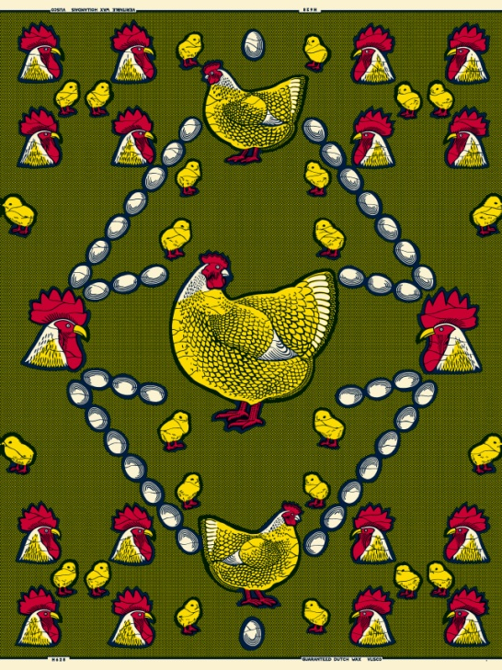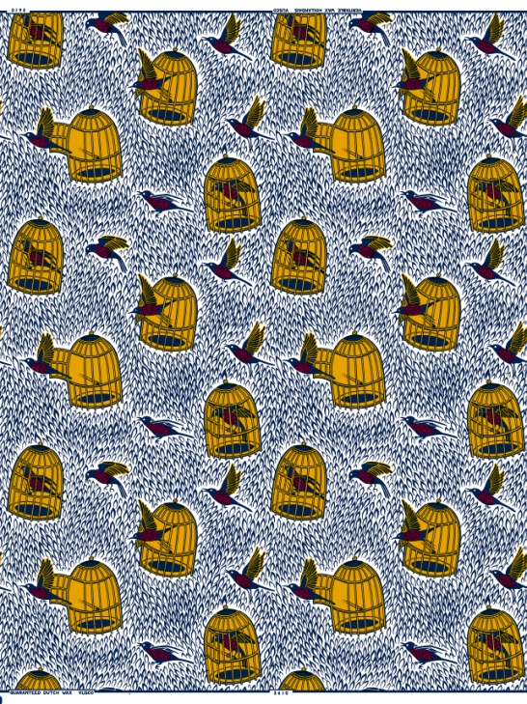
Figure 5 Happy family, 1905 Figure 6 Si tu sors, je sors, 1978
Another pattern shows an unlocked bird cage from which a bird has flown. At first glance it seems like a cheerful, innocent scene, but its name gives it a very different, secret meaning. The pattern is called ‘Si tu sors, je sors’ (If you leave, I’m leaving, too), and it can be seen as a signal from the woman to her husband: if you regard our marriage as a bird cage that you can fly in and out of as you please, then I’ll fly away, too, and you can go look for someone else (Fig. 6). The message of another pattern, ‘Six bougies’ (six cylinders), seems to suggest prestige: that the husband of the wearer has a big, expensive car. But in Africa it has acquired another meaning: that the wearer is a (sexually) strong woman who can take on six men (cylinders) at a time.
Whether one interpretation was intended over the other in these cases remains to be seen, since actually the messages are multi-interpretable. They allow the wearer to make a public statement about a situation in which she is expected to be silent, and to do it in a refined way. She can complain, issue a warning, even insult someone or make him look ridiculous, but she can never be attacked for it by her husband or by anyone else.
It was never the intention of the Vlisco designers, or any of the other Dutch manufacturers of wax prints, to incorporate secret messages in their designs. Nor were they responsible for naming the patterns. That was the work of the consumers or the market vendors. It was partly done for practical reasons: a name simply communicates more easily than the number assigned to the pattern by the factory in the Netherlands. Commercial motives also play a role, since the market women know all too well that a pattern with a name sells better. (Frans van Rood, interview with author, Geldrop, 7 September 2010). But the underlying reason is much more interesting. By giving a design a name − and thereby endowing it with a unique meaning − the African women appropriate the cloth produced in the West and make it part of their own culture. By means of naming, this foreign, European commodity is annexed and transformed into something that is truly their own. The European becomes the African. According to Bernadette Mpundu Mpia, many Congolese women don’t even know that Vlisco is Dutch: ‘They may say Real Dutch Wax but they don’t realise what it means. Vlisco belongs to us to a certain extent. It belongs to the Dutch, but it also belongs to the Congolese.’ (Bernadette Mpundu Mpia, interview with author, Kinshasa, 16 March 2011). Eric Loko, country manager for Vlisco in Benin, made the same observation: ‘For many generations, the tradition of wearing a pagne by Vlisco has been passed down from mother to daughter. This European product was adopted by us Africans, and it became part of our African identity in an entirely natural way.’ (Erik Loko, e-mail to the author, 31 May 2011).

Le dessin m’inspire, la couleur m’attire
The quality of the fabric is regarded by many consumers and stylists as an important reason to buy Vlisco. Another has to do with the unusual patterns and the warm, deep colours that are exactly the same on both sides of the cloth, which means they can easily be incorporated into all sorts of creations. ‘Women today love those lively, bright colours,’ says stylist Odia Kabakele. ‘When you see them, it puts you right in the mood to dress beautifully, completely African or in European style, in a blouse with a touch of ethnicity.’ (Odia Kabakele, interview with author, Kinshasa, 16 March 2011). ‘The design inspires me, the colour seduces me,’ says Bernadette Mpundu Mpia, who loves to mix styles and sometimes puts on a European-type dress, sometimes the classic deux pagnes that served as the daily traditional costume of the Congo for generations, and may even wear jeans in the weekend. But when she has to look representative she always chooses Dutch Wax, and always Vlisco because of the quality. (Bernadette Mpundu Mpia, interview with author, Kinshasa, 16 March 2011). Other young working women, such as Josée Muamba Odia, Sabine Viengele Mbangula and Vynka Malu, usually wear Western clothing when they go to the office because it’s more practical. But during evenings at home, in the weekends and certainly on special occasions like weddings and receptions, they prefer to wear Vlisco. They think it’s important to communicate their African identity, certainly in this age of internet and globalisation when the cultures are beginning to look more and more alike. For their mothers and grandmothers the pagne was the everyday dress and there was no other choice. But as women of a new generation, they themselves decide when they’re going to wear the pagne. And often those are times when they want to look very beautiful and to feel very special. (Josée Muamba Odia, Sabine Viengele Mbangula and Vynka Malu, interviews with author, Kinshasa, 16 March 2011).

Deconstruction, construction
A Western woman who wants a new dress will go to a shop, whereas an African woman will start searching for fabric. She’ll take the fabric to a dressmaker or stylist to have something beautiful made from it. Sometimes she’ll have her own vague idea of what she wants, and sometimes she lets herself be convinced by the ideas of the stylist. But usually the design is the product of joint collaboration, which is an important aspect of the whole process for both customer and stylist. Fashion magazines, films and television series, photos from advertisements, artists, the clothes of other women, clothes from other cultures, existing examples from the dressmaker’s own studio: anything can serve as inspiration for the new creation, which must be perfectly suited to the personality of the wearer and the occasions to which she expects to wear it. One essential element of the finished design, almost all the stylists say, is the pattern of the fabric. ‘You don’t just make something,’ says Odia Kabakele. ‘The design must do justice to the pattern, and vice versa.’ (Odia Kabakele, Myriam Ningi Lifeta, Élodie Elesse, interviews with author, Kinshasa, 16 (OK, MNL) and 15 and 17 (EE) March 2011). In this respect she and her colleagues are really breaking new ground. This would have been impossible twenty or thirty years ago, when cutting a Dutch Wax was simply not done. A Dutch Wax was a valuable possession; you could use it as a wraparound skirt, but afterward it would have to be carefully folded up and stored away. In this way the cloth retained its value: it was regarded as an investment, as a woman’s capital. When stylists and dressmakers pulled out their scissors at a certain point and began using the fabric to make dresses, blouses and skirts, it amounted to a minor revolution. (Betty van Breemaat, international market researcher at Vlisco, interview with author, Helmond, 23 September 2010). But the current generation of stylists have gone one step further. They not only cut the fabric, but they also cut bits out of the fabric, deconstructing the patterns, as it were, and using the cut-out elements to make new, unique patterns. This is exactly the method used by the aforementioned Lamine Kouyaté for his label Xuly Bët.
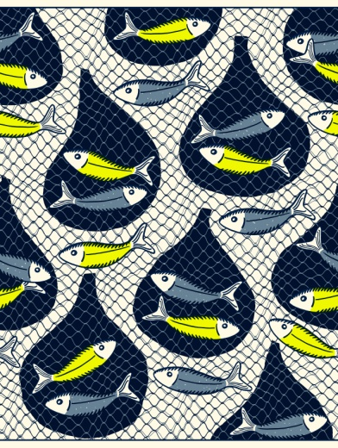
Figure 7 Tableau Vivant collection,2010 Figure 8 Design by Élodie Elesse, Kinshasa 2011. Photograph: Jos Arts

Élodie Elesse cuts the fish out of a pattern from the Tableau Vivant collection, for example, and sews them back together to make an elegant blouse (Fig 7 and 8). Myriam Ningi Lifeta is inspired by the round shapes in a pattern, cutting them out to make openwork circles that she uses as ornaments on a dress from the same fabric. And in her creations, Odia Kabakele not only mixes Dutch Wax with materials such as lace and kente, but she also mixes the traditional Korean costume with the African boubou. (Odia Kabakele, Myriam Ningi Lifeta, Élodie Elesse, interviews with author, Kinshasa, 16 (OK, MNL) and 15 and 17 (EE) March 2011). ‘We live in the twenty-first century,’ Kabakele says, ‘a time in which individuals, peoples and cultures are becoming more and more intermingled. So let’s not limit ourselves to a single classic Congolese clothing model. The world has become one big melting pot.’ (Odia Kabakele, interview with author, Kinshasa, 16 March 2011).

Conclusion
Incorporating foreign elements into native fashion; the creative re-use of second-hand clothing; the naming of and conferring of meaning to Dutch Wax; the system of stylists, fashion studios and clients: these are specifically African phenomena, and they give African fashion an entirely new face. Even a prestigious product, but one that is fully designed and produced in Europe like Vlisco’s Real Dutch Wax, is not indiscriminately and unquestionably accepted. On the contrary, Dutch Wax has been subtly integrated into African culture in a variety of ways, with the deconstruction of textile patterns as the most radical example. Tunde Akinwumi’s refusal to see Dutch Wax as African fashion not only fails to appreciate the cross-border, continuously changing character of fashion, but it also fails to appreciate the power and inventiveness of the African woman, who has managed to adapt and transform Dutch Wax into an integral part of her own African identity, as she did with so many other ‘foreign’ elements.

References
Akinwumi, Tunde M., ‘The “African Print” Hoax: Machine Produced Textiles Jeopardize African Print Authenticity’, The Journal of Pan African Studies, 2 (July 2008), no. 5, pp. 179-192; www.jpanafrican.com/docs/vol2no5/2.5_African_Print.pdf
Bender, Wolfgang, ‘Omo Laso (Kinderen zijn onze kledingstukken)’, in: Bea Brommer (ed.), Katoendruk in Nederland. Exhibition catalogue, Nederlands Textielmuseum Tilburg / Gemeentemuseum Helmond, Tilburg/Helmond 1989
Domowitz, Susan, ‘Wearing Proverbs: Anyi Names for Printed Factory Cloth’, African Arts, 25 (1992), no. 3
Gott, Suzanne, ‘The Ghanaian Kaba’, in: Suzanne Gott and Kristyne Loughran (eds.) Contemporary African Fashion, Bloomington /Indianapolis (Indiana University Press) 2010
Hansen, Karen Tranberg, ‘Secondhand Clothing and Fashion in Africa’, in: Suzanne Gott and Kristyne Loughran (eds.), Contemporary African Fashion, Bloomington/Indianapolis (Indiana University Press) 2010
Heringa, Rens, ‘Javaanse katoentjes’, in: Bea Brommer (ed.), Katoendruk in Nederland. Exhibition catalogue, Nederlands Textielmuseum Tilburg / Gemeentemuseum Helmond, Tilburg/Helmond 1989
Jacobs, M. and W. Maas, Een leven in kleur: Textieldrukkerij Vlisco 1846-1996, Den Bosch (Historion) 1996
Krantz, C.H., ‘De export van in Nederland bedrukte katoen naar het Verre Oosten en Afrika’, in: Bea Brommer (ed.), Katoendruk in Nederland. Exhibition catalogue, Nederlands Textielmuseum Tilburg / Gemeentemuseum Helmond, Tilburg/Helmond 1989
Kroese, W.T., ‘De oorsprong van de wasdruktextiel op de kust van West-Afrika’, Spiegel Historiael, 13 (1978), nr. 3, pp. 147-157
Leyten, Harrie, ‘Geheime boodschappen in wax prints’, in: Robin van Koert, Dutch Wax Design Technology: Van Helmond naar West-Afrika, Eindhoven (Lecturis) 2008
Luttmann, Ilsemargret (ed.), Mode in Afrika: Mode als Mittel der Selbstinszenierung und Ausdruk der Moderne. Exhibition catalogue, Museum für Völkerkunde, Hamburg 2005
Nielsen, Ruth, ‘The history and development of wax-printed textiles intended for West Africa and Zaire’, in: Justine Cordwell and Robert Schwarz (eds.), The Fabrics of Culture: The Anthropology of Clothing and Adornment, The Hague/New York (Mouton) 1979
Picton, John, The Art of African Textiles: Technology, Tradition and Lurex. Exhibition catalogue, Barbican Art Gallery, London (Lund Humphries) 1995
Rabine, Leslie W., The Global Circulation of African Fashion, Oxford/New York (Berg) 2002
Rodenburg, G.H., ‘Dutch Wax-Block-Garments’, in: Textielhistorische Bijdragen (1967); www.historischcentrumoverijssel.nl
Rovine, Victoria L., ‘African Fashion’, in: Suzanne Gott and Kristyne Loughran (eds.) Contemporary African Fashion, Bloomington /Indianapolis (Indiana University Press) 2010
Steiner, Christopher B., ‘Another image of Africa: Toward an ethnohistory of European cloth marketed in West Africa, 1873-1960’, Ethnohistory 32 (1985), no. 2, pp. 91-110

This research was made possible by ArtEZ Institute of the Arts. The monograph Vlisco, was published at WBOOKS/ArtEZ Press in 2012.
The name of the company was changed to Vlisco in 1970.

