Emotional Conscience: Beyond the periphery of educational language.
This paper aims to disseminate the need for fashion educators to accept responsibility for re-shaping the moral attitudes of our future fashion designers, specifically relating to issues of diversity, beauty, image and size.
Fashion and beauty are symbiotic components in a global and expanding industry. Permeating the consciousness of consumers worldwide, an unrelenting stream of visuals from television and film, to popular culture, arts and literature relay the current prognosis for supposed image and beauty ideals. Fashion, in its breadth of multifaceted components, serves as a hypercritical dictator of beauty and body ideals, communicating an unrepentant and often subliminal critique of the human form.
The fashion industry stands firm against criticism for its continual promotion of airbrushed teenage models, whose altered body proportions and plasticized skin clearly bypassed the design of natural evolution. Designers and fashion influencers continue to seek impacting marketing strategies through advertising campaigns and magazines where supposedly inspirational images of beautiful women are dependant on altered artifice and impossible youth.
This paper will explore new territories of educational language, and will argue for the need for a global recognition and commitment to improving the self-esteem of consumers through emotionally considerate design, marketing and branding. Through creative projects and challenging academic research the aim is to promote and reinstate a healthier attitude towards diverse image and beauty. In uniting academics across the spectrum of fashion education, the anticipated re-shaping of student thinking will ultimately impact positively on the future of the fashion industry.
Mal Burkinshaw, MA RCA, is Programme Director of Fashion at Edinburgh College of Art, University of Edinburgh and Director of the All Walks Beyond the Catwalk Centre of Excellence for Diversity*
*All Walks Beyond the Catwalk is an initiative created by Fashion Commentator Caryn Franklin, PR Expert Debra Bourne and model Erin O’Connor.

1: Fashioning Bodies
The topical issues of body image and beauty associated with fashion design continue to be highly relevant and controversial. There is clear academic and anecdotal evidence that there are issues with image in the fashion industry. Concerns relating to the use of underweight and underage models within high profile fashion campaigns and catwalk shows contribute to poor body image (particularly in women and girls) and unsatisfactory retail experiences. The fashion industry continues to play a significant role in shaping the way that we perceive the body and beauty, albeit through an overwhelmingly homogenized approach to individuality and identity.
The 21st century has witnessed a significant shift in standards relating to body aesthetics. Our modern ideals of beauty and body image represented through fashion imagery are, it might be argued, in stark contrast to the era of the supermodels, largely acknowledged as an integral part of late twentieth century beauty and image culture. During this era, models such as Helena Christiansen, Tatjana Patitz, Naomi Campbell, and Linda Evangelista epitomized a more diverse, athletic and toned body type, which in turn communicated health, individuality and empowerment.
Body and beauty issues are as cyclic as hemlines and shoulder widths; yet there is little firm commitment from the fashion industry to promulgate healthier messages to consumers in a sustained way. Essentially, there is a lack of commitment to create strategies whereby health and wellbeing is part of the objectives of fashion design and promotion. Cumulatively, it seems that the emotional needs of the population are not in synchrony with the agendas of the fashion industry.
Italian Vogue, the revered fashion publication, known for its visionary and artistic approach to fashion photography, has been swift to respond to the latest movement towards healthier body communication. The June 2011 issue broke the norm for such high fashion publications, by placing three ‘plus size’ models, Tara Lynn, Candice Huffine and Robyn Lawley on it’s cover. Franca Sozzani, Editor in Chief of Vogue Italia, told Women’s Wear Daily ‘Why should these women slim down? Many of the women who have a few extra kilos are especially beautiful and also more feminine.’ (Kattalia, K. 2011)

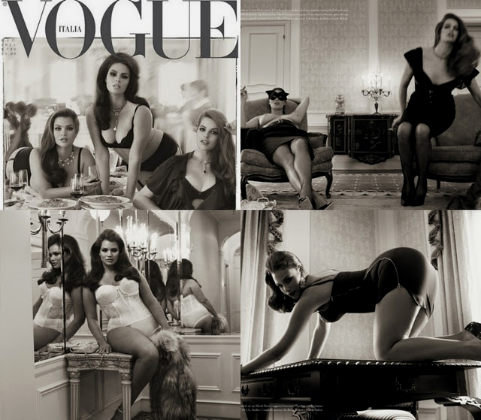
Fig 1: Vogue Italia, June 2011.
Additionally Sozzani created a petition against ‘pro-anorexia websites’ and acknowledged the increasing dilemma of the use of underage and underweight models. Sozzani stated, ‘models, as I have underlined before, are in most cases naturally long, lean and slender, being still very young and still not fully developed. The image they convey, however, is often that of excessive thinness.’ (Kattalia, K. 2011)
Vogue Italia, considered as the most elite and influential fashion tome, appeared to herald a new era of body and beauty diversity within high fashion. However, and upholding the transient nature of fashion fads, the subsequent September issue unraveled the magazine’s stance on progressive thinking. Featuring model Stella Tennant and photographed by Steven Meisel, the front cover and associated photographs, based on an image of English corset maker Ethel Granger, imagined the model in a variety of cinched corsets.
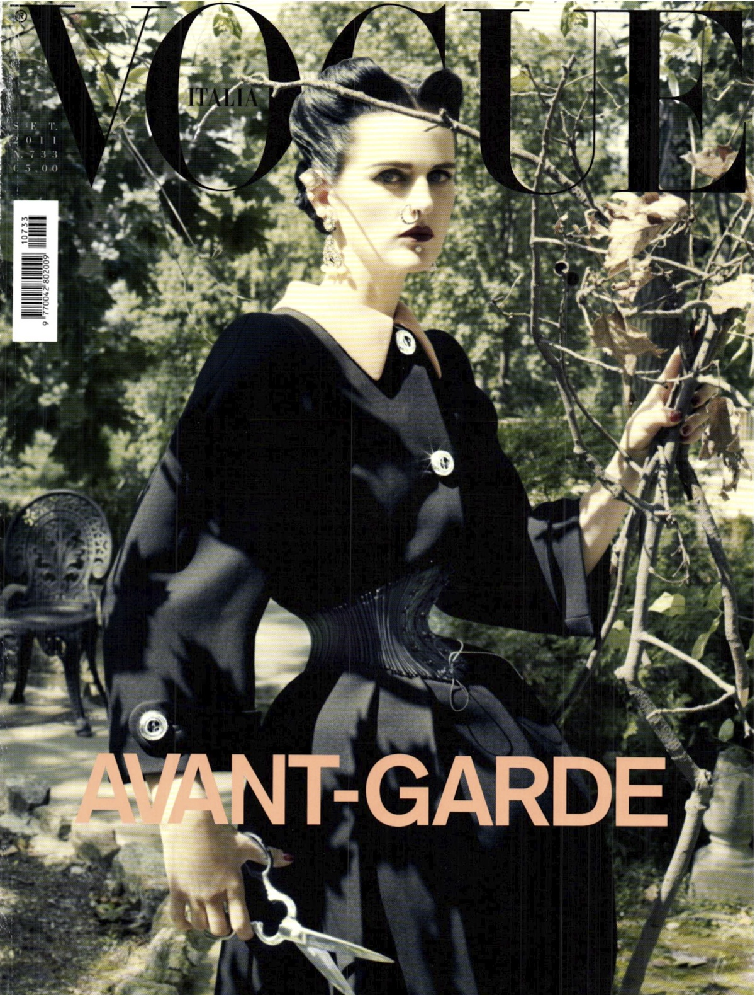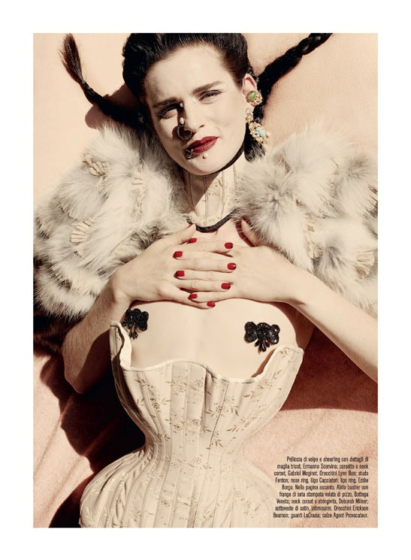
Fig 2: Vogue Italia, Stella Tennant by Stephen Meisel, September 2011.
When one considers such polarity of thinking and contradictory visual language, the positive messages conveyed in the June issue are significantly and disappointingly diminished. One should consider that, although clearly an editorial based on notions of fantasy, the pro – anorexia websites that Sozzani referred to must surely have been further propelled by such ‘excessive thinness’ that she previously disparaged.
Additionally, Vogue executive news director, Carlo Ducci displayed a worryingly dismissive attitude towards public reaction to the feature, which further enforced such a hypocritical u-turn. Ducci commented ‘Our magazine drew on reality. If this reality is perceived as bad, this is not our problem.’ (Smith, G. 2011)
The reality of the fashion industry is to use models that represent a size 0-4 (UK). There is little doubt that the self esteem and body confidence of consumers seeking inspirational body and beauty icons is both threatened and harmed by this ‘reality’. When one considers that previously derided controversially thin models, such as Kate Moss, Jodie Kidd, and Jaime King, were representative of a minority body type in the mid to late 1990’s, we now see that their proportions are the accepted norm within the industry, and a size 10 – 12 is considered ‘outsize’.
Fashion designers insist on using marketing strategies that advertise their work through highly selective choices of fashion model. As a consequence, the designer becomes responsible for creating a visual language of beauty and body ideals, and plays a significant part in molding the zeitgeist of the era. Many designers are unhappy to accept their role in influencing beauty and body ideals, and often berate being treated as scapegoats for the epidemic of eating disorders and self-esteem related problems.
Recent advertising campaigns by leading brands Miu Miu and Marc Jacobs showcasing actresses Elle Fanning (age 13) and Dakota Fanning (age 17) respectively, have courted controversy by seemingly sexualizing child imagery. Encouragingly, the Advertising Standards Authority banned the Marc Jacobs perfume advertisement, stating, ‘We considered that the length of her dress, her leg and position of the perfume bottle drew attention to her sexuality. Because of that, along with her appearance, we considered the ad could be seen to sexualize a child. We therefore concluded that the ad was irresponsible and was likely to cause serious offence.’ (Sweney, M. 2011)
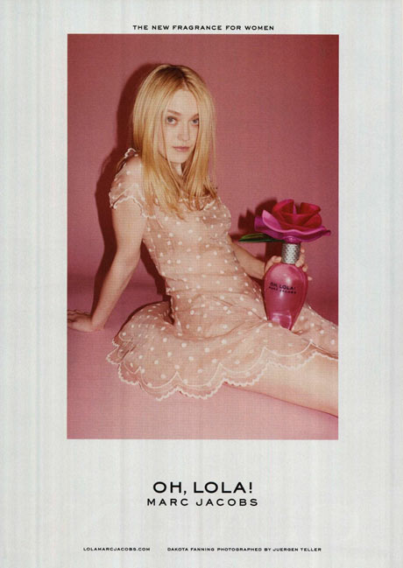
Fig 3: Dakota Fanning for Marc Jacobs.

The obsession with fashion and youth is relentless, with an increasing number of designer brands endorsing their products through pubescent actresses such as Chloe Moretz (14) and Haylee Steinfeld (14) and there is little evidence to support a change in the way designers view age and beauty. Ironically the average income earners to buy such brands are placed with the 40 – 60 year old age bracket.
Tom Ford, previously appraised for the resurgent success of the Gucci brand, and subsequently designer of his own label famously stated; “To me, beauty and sadness are very closely linked. Truly beautiful things make me sad because I know they are going to fade. When I see a beautiful 20-year-old boy or girl––and they are breathtaking––I am filled with a kind of sadness. But maybe they are beautiful because we know they are not permanent and they are in a kind of transition.” (Sessums, K. 2010)
Such grandiose emotive statements proceed to enforce an extremely narrow articulation of beauty. Through an emphasis on the fading of youth in symbiosis to a fading of beauty, and one might conclude, a fading of self-esteem, this reinforces the notion that designers play a vital role in influencing attitudes towards body and beauty standards.
Paradoxically, Tom Ford proceeded to create a catwalk show for his Spring/Summer 2011 collection using a diverse selection of models including actresses Lauren Hutton and Julianne Moore, models Stella Tennant and Naomi Campbell and pop singer Beyonce. This showcase, a celebration of beauty, sophistication and maturity disappointingly barred press and media coverage.
Upholding Fords previous principle of youth and beauty, the industry promotes unrealistic body and beauty ideals to a worldwide consumer base through subliminal and deceptive means. One must question the emotional communication of such dangerous messaging; if these images are describing modern ideals of beauty, yet the models are themselves childlike, women are aspiring to a body aesthetic that is wholly unrealistic and unobtainable. Add to this the high probability that the images may have been subjected to a degree of enhancement and modification through airbrushing and digital manipulation, and this ‘beauty ideal’ represents artifice in the strongest sense of the word.
Susie Orbach, psychotherapist, psychoanalyst, writer and social critic further explains the modern demands of unrealistic perfection in her book ‘Bodies’. Orbach writes, ‘Our visual world is being transformed through an intensification of images which represent the body and parts of the body in ways that artfully convey a sense that our own bodies are seriously in need of re-shaping and updating. Without even noticing we may willingly accept the invitation, eager to stay up to date’. (Orbach, S. 2010. P4)

2: Body Force
Whilst the fashion industry continues to demonstrate subliminally dangerous marketing campaigns through propagation of elite body architecture and facial uniformity, there is evidence of a more committed and dynamic movement towards promoting healthier attitudes towards diversity of body size, age, height and beauty within UK fashion. All Walks Beyond the Catwalk is an initiative founded by fashion commentator Caryn Franklin, PR Expert Debra Bourne and model Erin O’Connor, with a vision to incite change and implement a more positive attitude toward body image and beauty diversity to the fashion industry.

The All Walks project has worked with established brands in British fashion from Vivienne Westwood and Giles Deacon to Stella McCartney. In 2011, the initiative also commissioned international photographer Rankin to create diverse All Walks fashion portraits shown at the National Portrait Gallery under the title ‘Snapped’. Additionally, in June 2010, All Walks presented the first education forum at Graduate Fashion Week in London to instigate collaborative opportunities for fashion institutions interested in exploring the theme of diversity within their curriculum.

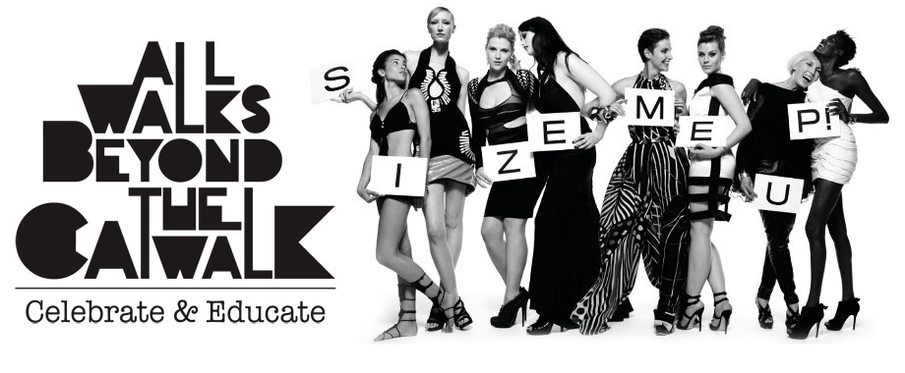
Fig 4: All Walks Beyond the Catwalk

Caryn Franklin states, ‘we live in a diverse world, and it’s time to join the dots between commercial thinking and emotional understanding. The fashion industry can send out a more conscious message, develop a more emotionally considerate practice in pursuit of a more lucrative b business proposition. It all begins in education.’ (Franklin, C. 2011)

3: Educating Bodies
In June 2011, UK Government Minister Lynne Featherstone launched the All Walks Centre of Diversity at Graduate Fashion Week, London, as an important hub for developing innovative educational methods. Mal Burkinshaw, Programme Director of Fashion at Edinburgh College of Art, directs the Centre of Excellence in promoting a healthier attitude to diversity within fashion education.

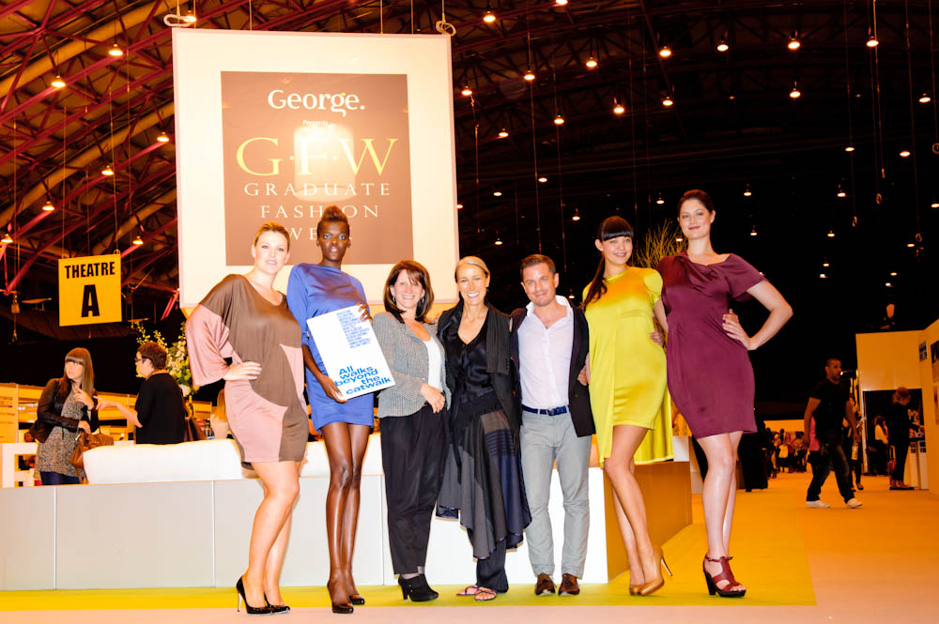
Fig 5: MP Lynne Featherstone, Caryn Franklin and Mal Burkinshaw with All Walks Models in ECA student designs, at Graduate Fashion Week, June 2011.
The philosophy of the Centre promotes the responsibility of fashion educators to teach future fashion designers and influencers the importance of developing emotional consideration to the wearer through creative and exciting educational methods. As such, the Centre will connect to academics across the UK to share best practice on the theme of Diversity. Such exchange of expert knowledge will strengthen the core delivery of design education both nationally and internationally.
The Centre identified that students have a tendency to design for an industry standard model proportion, without fully considering how their work will appeal and address a wide spectrum of consumer diversity. By allowing students to place such focus on fashion shows and models as sole end context for their work, educators become increasingly responsible for encouraging a restrictive and elitist industry that works against the notion that fashion design should be accessible to all.
The Centre has placed an emphasis on directing the educational message to early stages of the fashion curriculum in order to impress the need for a new way of thinking about design with a consideration to body and image. As a result, the students will apply emotionally considerate design as an inherently natural and fully integrated component of design process and design product.
Jo Swinson: Liberal Democrat MP and co-founder of the UK Government Campaign for Body Confidence recently noted the work of the Centre of Diversity, “When I visited the All Walks Centre of Diversity I was incredibly impressed by the commitment, leadership and vision displayed. I think that the students will become better designers who understand how people will feel to wear their clothes, and they will help to create a world of fashion that appreciates the diversity of beauty in the human form.” (Swinson, J. 2011)
In addition, a research network for Emotionally Considerate Design has been established in collaboration with All Walks Beyond the Catwalk. The Emotional Engagement Project unites academics and industry experts from the spectrum of UK fashion education aiming to underpin academic teaching delivery with dynamic and innovative research into design for diversity. The project received seed funding from the Scottish Academy of Fashion to initiate the development of leading educational and research projects asking students and fashion industry sectors to celebrate and address a more diverse approach to body image and beauty through fashion design and marketing. The Centre acknowledges the importance of developing healthier educational messaging about body image and beauty. In recognizing that our design students will ultimately shape the future of the industry, the research network will work with students and educators to develop ‘new languages’ for diversity.

4: ‘Body Icons’
In the session 2010/2011, The All Walks Centre at Edinburgh College of Art introduced the Icon Project to the educational curriculum, asking students to address the subject of Emotionally Considerate Fashion Design. The students were asked to design a dress for a woman who represented diversity of image, set apart from the prototypical catwalk standard. The selected women demonstrated a broad demographic addressing race, age, height and size. Each student was connected with a different woman, referred to as an ‘Icon.’ This term was used as a celebratory linguistic tool to heighten the ways that the students would perceive their model.
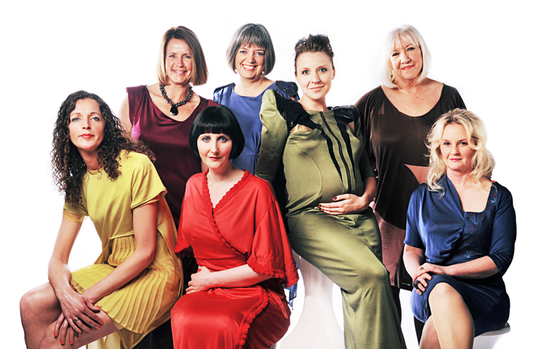
Fig 6: The Icon Project 2011
The intention of the project was to widen and challenge the student’s perceptions of beauty and body image within fashion design, pattern cutting, illustration and fashion marketing. The students were required to research and develop an understanding of their Icon’s emotional outlook on a range of fashion related subjects, including her views on body self confidence and her own perceptions of beauty and self esteem.
Embedding an understanding of the importance of language within the project was commensurate to ensure its success. From the initiation of the project the student group were required to develop a considerate approach within inter-personal interactions with their model. An emphasis was placed on the importance of language as a tool to increase self-esteem and body confidence. Similarly, effective and considerate management of language became a focus for lecturing staff whose role was to manage key aspects of the project and to oversee any problematic scenarios. An instance, where on reflection, language proved to be crucial, arose when one student approached a lecturer over concerns about her models size. The student, highly upset, explained that her design was ruined because the Icon had put gained weight and consequently the dress did not fit as intended.

The design lecturer identified to the student the importance of reacting in a positive manner and using celebratory language to describe the ‘beautiful new body’ that the Icon had developed. The lecturer addressed the problem with positive thinking, rather than to re-enforce any negative connotation’s concerning weight gain. The student was further encouraged to arrange fittings where she would use complimentary language about her Icons body shape, to ensure that the individuals self esteem was not affected. The lecturer was able to shift the paradigms of body ideals for this student, who was able to re-address her perception of ‘ideal’. By raising awareness of the emotional effect of good design and communication, the student developed a deeper understanding of the human form, and the role that fashion plays in respecting and celebrating diversity.
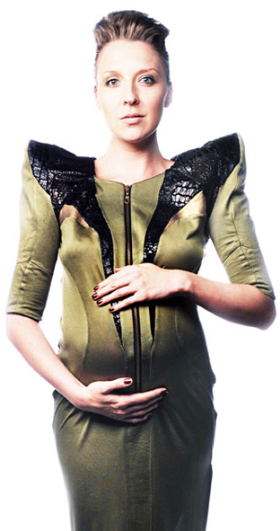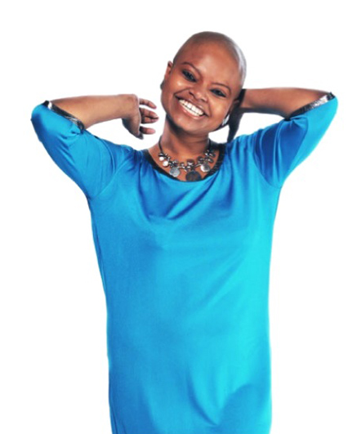
Fig 7: Student designs, All Walks Icon Project 2011
After the project, key issues arose concerning the teaching methods academics use when referring to the body. It was agreed that there is no established or clear ‘vocabulary guide’ within fashion education and interaction with students that encourages students to develop a healthy attitude towards body image and beauty. The lecturing team discussed and concluded the following points related to educational vocabulary and the body:
- Lecturers and students refer to body size in rudimentary senses, normally numerical, i.e. “she’s a 12”.
- Lecturers used standard and popular terms for describing body shape, such as ‘curvy’, ‘slim’, ‘tall’, ‘small’, ‘hourglass –shaped’, ‘pear – shaped’.
- Lecturers do not regularly emphasize the importance of the real human body as the foundation for effective design solutions; rather an emphasis is placed on working on tailors mannequins, with no arms, legs, or head (or opinions!)
Fashion designers continue to gain notoriety for forming derisive doctrines of language about the body, which in turn achieve wide press coverage, subsequently addressing and mocking a wide audience. Designer Karl Lagerfeld commented on the decision by German Magazine Brigitte to feature ‘normal sized women’, stating; "These are fat mummies sitting with their bags of crisps in front of the television, saying that thin models are ugly," "no one wants to see round women". (Connolly, K. 2009)
Whilst the acerbic statement alone is shocking, it is the use of such basic language about the body; from a designer who understands the way that fabric and cut should celebrate the human form, which is surprisingly limited. Whilst one cannot challenge Lagerfeld’s right to freedom of speech for any press he desires worthy, there is such an obvious emphatic irresponsibility aligned to his derisory ‘body language’.
The way that highly influential designers discuss the body contributes to the creation of an elitist set of cultural rules about body diversity acceptance. One quote from a designer as influential as Lagerfeld will undoubtedly damage the self-esteem of numerous women whose body type he refers to. As a result the symbiotic relationship between self-image and language about the body cannot be underestimated. Vitally, whilst it is accepted that fashion design and associated fashion marketing provides clear yet dubious visual languages, it becomes imperative that verbal language also forms and influences perceptions of body and beauty issues.
The Centre of Diversity agreed that research should be undertaken to explore the use of more celebratory words about the body during tutorial interaction, and to engage with students to develop new methods of talking about body and beauty diversity. The team decided to develop a strategy to ascertain how a deeper level of knowledge about language and image can be integrated within fashion education to convey a healthier approach to body and beauty perception.
The strategy outlined three key areas of enquiry:
- To develop a creative project where students will evidence experimentation of vocabulary relating to the body.
- To develop informative educational tools to increase the awareness and importance of using celebratory language in reference to body diversity.
- To use this information to develop trial interaction between educators at the Centre and student in order to analyze the effectiveness of new ‘body language’.

5: ‘Body Talk’ -The All Walks Centre of Diversity Project in Collaboration with the Scottish National Portrait Gallery, Edinburgh.
For the academic session 2011/2012, The All Walks Centre for Diversity designed and implemented a creative design project titled ‘The Body Project’. Split into two-core project components – the project aimed to strengthen how students address and celebrate diversity of body image and beauty through fashion design, with language at the heart of the design process.
The first stage of the project, in collaboration with the Scottish National Portrait Gallery in Edinburgh, placed emphasis on the importance for students to achieve a critical and historical underpinning of the way that beauty has been represented and perceived historically. Following a focus group with students, it transpired that they perceived the idea of ‘altered fashion imagery’ through airbrushing and associated computer techniques to be a relatively modern concept.
The Body Project required students to analyse how Scottish Portraiture circa 16thC to the present day represented and celebrated diversity of the body and beauty through artistic representations. The students, at an early stage of their fashion design education, were able to understand how a plethora of diverse body types have been celebrated as inspirational beauty through periods in history. By directing students towards a more theoretical focus of study, it was anticipated that the understanding of ‘trends’ for airbrushing and artifice within fashion promotion would be placed within a much wider context, and therefore students might understand how beauty is subject to the ‘zeitgeist’ and of individual perceptions by their respective image-makers.
The project has explored methods to encourage language skills used by students in reference to the human body and beauty, anticipating a re-shaping of thinking. Following their research visit to the Scottish National Portrait Gallery in Edinburgh, the students were requested to display an exhibition of adjectives to describe and celebrate diversity of the human form. The students worked in small groups to reflect on the diverse representations of body and beauty represented through the artwork studied at the Portrait Gallery. The event, ‘Body Talk’, held on November 31st 2011, showcased 251 independent words describing body and beauty.

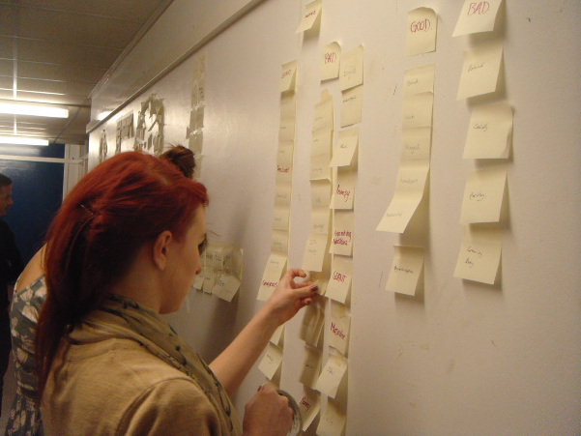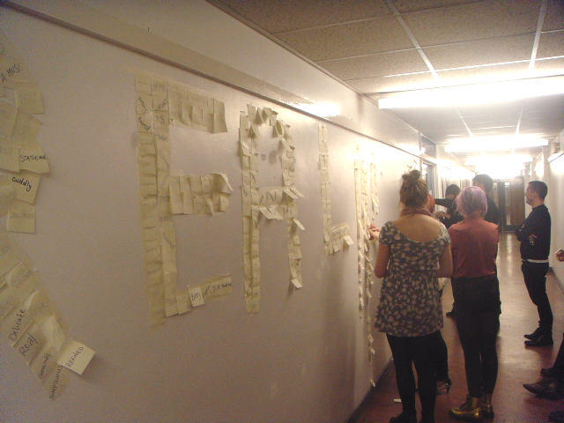
Fig 8: The Body Project Language Lab: Body Talk 2011
Subsequently, the Centre initiated an analysis of the words, organising them into clear categories:
Uncommon celebratory words: this category contained words, which are clearly celebratory through their meaning yet it is agreed that they are not commonly used in relationship to the body or beauty. Examples of the words are given below:
Willowy, Alabaster, Sonsie, Captivating, Sumptuous, Lissom,
Common celebratory words: This category represents common adjectives relating to body and beauty demonstrating a celebratory meaning. Examples of this category include:
Pear, Peachy, Slender, Lean, Voluptuous, Tall, Feminine, Slim, Curvy, Apple, Petite, Glamorous, Beautiful, Gorgeous, Slight, Trim, Athletic, Statuesque.
Non – Celebratory words used to describe body image and beauty: This category reflects adjectives that the students perceived to be positive yet would be commonly interpreted as negative, or may have a detrimental effect to self -esteem. Examples include:
Chubby, Big- boned, Plump, Top heavy, Ample, Pale, Sturdy, Bony, Lanky, Stumpy, Scrawny, Strange, Gigantesque, Pint-sized, Portly, Broad, Rotund, Busty.
Ambiguous words to describe body image and beauty: this category outlines words that can be used with double meaning, and may be considered to be celebratory or non celebratory.
Skinny, juicy, grand, womanly, cuddly, stately, well-defined, succulent, ripe, bold, weathered.
Non-appropriate words to describe body image and beauty: this section demonstrates words that do not define any particular relationship to the body or beauty.
Byronesque, crafted, light, muse, affluent, inviting, confidence, fluorescent, titivating, fruitful, regimented, notorious, mint.
The chart below demonstrates the percentage breakdown for each category:
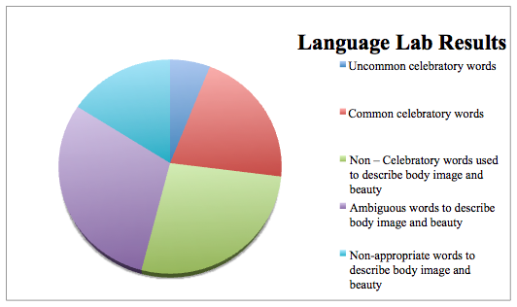
The language lab study allowed the Centre of Diversity to gain a crucial awareness of language that fashion student’s use in reference to the body and beauty. The study demonstrated that there are limited new words expressed to celebrate the body and suggested that new language can be developed to find more celebratory words to describe the body and beauty diversity within fashion education.
The lecturers noted the inclusion of one word, ‘Sonsie’, which was commonly not known to them. Student Bella Macleod, who exhibited this word for the language lab explained; “The reason why I know of the word is because it is in the poem written by Robert Burns called 'Ode to a Haggis'/'Address to a Haggis', The line in which it is used is: 'Fair fa' your honest, sonsie face, great chieftain o' the pudding-race,' referring to the actual Haggis itself as having an abundance of things to offer; with it also therefore being round but in a plump, attractive way. I think this is the link that I have with the word when using to describe a woman who is curvaceous and beautiful. When I think of the word Sonsie it conjures up the image of someone whose curves are not only beautiful and pronounced but at the same time comforting”.
This old Scottish word, and the student’s awareness of it, demonstrates the potential for further research into ‘lost’ historical words that might be re-instated as part of modern language to celebrate the body and beauty. It is intended that this will become an area of investigation for the long-term research project. Additionally, the exhibition clearly communicated a surprising amount of words that students felt were celebratory, but when used to describe the body, may be construed as offensive. Such a misplaced understanding of word meaning and intent demonstrates a rudimentary appraisal of body diversity, which the Centre concluded must be addressed through further educational projects.
Further teaching experimentation methods were implemented into the project to enhance and develop the way that students perceive the body. Using weekly life drawing classes, fashion students were encouraged to explore the nude form through detailed drawing studies. Following this experience the students were asked to conduct a second ‘language lab’ to allow the lecturers to see if their perspectives on body and beauty had been altered. This experiment evidenced a shift in the way students used words to describe the body, and the words generally conveyed a more sophisticated and sensitive perception of the body.
Most interestingly, the second language lab generated only sixty-three adjectives, perhaps evidencing a more considered approach. Additionally only eight of these words could be placed in alternative categories, with no words being used that may be deemed offensive or derogatory. Overall, a more academic and empathic consideration of beauty and body was demonstrated and noted. Examples of these words were: Becoming, graceful, undulating, poised, dynamic, vivacious, lissome, gracious, scintillating, stunning, statuesque, fine-featured, striking, captivating, fascinating.
The students embedded the language workshops within their project, and developed a highly successful illustrated design project, where the body was ultimately the research inspiration for the garment design. The students feedback on the project was largely highly positive and demonstrated how inspirational such educational approaches can be. Fashion student Lillian Archibald commented, “I really enjoyed this project and feel it is such an important thing to celebrate diversity in bodies. I am very excited for the next stage of my studies.”
Conclusion:
Whilst issues relating fashion and image to health and wellbeing are certainly not new subject areas, there is demonstrative evidence that education can move beyond the periphery of its restrictive knowledge about beauty and body image. This paper has sought to express why more initiative must be taken by fashion educators to encourage students to explore an emotionally considerate response to body and beauty diversity within design.
A change is required in the way that we, educators, talk to our students about the body, and we must proceed to create new paradigms, re-focusing design dialogue towards the true context of fashion, a human body, rather than the sole body of a model stereotype or an airbrushed image in a magazine. As Susie Orbach explains, ‘We experience the wish for more perfect bodies as our own desire, as indeed it is, yet it is hard to separate out the way bodies are seen talked about and written about and the effect of that on our personal perception of our own bodies and other bodies’. (Orbach, 2010. P4)
Educators readily accept that our students are the future of the fashion design industry and as such they will have the capacity and expert knowledge to inform and influence the way in which the industry views, represents and celebrates diversity of body and beauty to a worldwide demographic. Students who demonstrate an empathic understanding of the body and beauty will intuitively transfer this knowledge to their design process, and their products will become more considerate and diverse as a result.
By exploring new territories for fashion education, in particular a commitment to a sustained implementation of emotionally considerate design, the All Walks Centre of Diversity represents an honest, and contemporary approach. The Centre believes that innovation and language should be placed at the core of changing body image and beauty perceptions, and in breaking strict doctrines set by ever burgeoning fashion artifice. Fashion and fashion imagery should be inspiring, obtainable, healthy and more importantly, diverse.

References
Orbach, S. (2009) Bodies, London: Profile Books Ltd.
Connolly, K. (2009) Karl Lagerfeld says only 'fat mummies' object to thin models. Available from: http://www.guardian.co.uk/lifeandstyle/2009/oct/12/lagerfeld-size-zero-thin-models. Accessed 24.10.11

Franklin, C. (2011) Scottish College Champions Catwalk Diversity. Available from: http://campaignforbodyconfidence.wordpress.com/2011/06/07/328/. Accessed 24.10.11
Kattalia, K. (2011) Italian Vogue editor Franca Sozzani launches petition to stop pro-anorexia websites, blames Facebook. Available from: http://articles.nydailynews.com/2011-03-18/entertainment/29179464_1_pro-ana-disorders-pro-anorexia. Accessed 13.11.11
Sessums, K. (2010) Tom Ford Tells All. Available from: http://www.advocate.com/printArticle.aspx?id=101321. Accessed 7.11.11
Sweney, M. (2011) Marc Jacobs' Dakota Fanning ad banned for being 'sexually provocative'. Available from: Accessed: 02.12.11
Smith. G. (2011) Cover of Italian Vogue Sparks Controversy. Available from: http://www.thefreshoutlook.com/?p=3985. Accessed 26.11. 11
Interviews:
MP Jo Swinson, 11.16. 2011.
Bibliography:
Barnard, M. (1996) Fashion as Communication. London: Routledge.
Bippus, E and Mink, D. ( 2007) Fashion Body Cult. Stuttgart: Arnoldsche Art Publishers
Giuntini, P and Hagen, K. (2008) Garb, A Fashion and Culture Reader. New Jersey: Pearson Education Inc.
Holland, S. (2004) Alternative Femininities Body, Age and Identity. Oxford: Berg
Ledoux, J. (1998) The Emotional Brain. London: Pheonix, Orion Books Ltd.
Neuman, S and Stephenson, G. (1993) Reimagining Women. Canada: University of Toronto Press.
Orbach, S. (2009) Bodies. London: Profile Books Ltd
Rodic, Yvan. (2010) Facehunter. London: Thames and Hudson Ltd.
Yurchisin, J and Johnson, K. (2010) Fashion and the Consumer. Oxford: Berg.

Images:
Fig 1: Meisel, S. June 2011, Vogue Italia. Available at: (http://scandinavian-berry.blogspot.com/2011/06/steven-meisel-for-vogue-italia-june.html).
Fig 2: Meisel, S. September 2011 Vogue Italia. Italy, Conde Naste Publications.
Fig 3: Teller, J. 2011. Marc Jacobs, Oh Lola! Available at (http://www.guardian.co.uk/media/2011/nov/09/marc-jacobs-dakota-fanning-ad-banned)
Fig 4: Courtesy All Walks Beyond the Catwalk, 2010. Available at: www.allwalks.org.
Fig 5: Courtesy All Walks Beyond the Catwalk, 2010. Available at: www.allwalks.org.
Fig 6: Isola Crolla, A. 2011 All Walks Icon Project 2011. Photograph by Anna Isola Crolla. Copyright owned by Edinburgh College of Art, University of Edinburgh.
Fig 7: Isola Crolla, A. 2011 All Walks Icon Project 2011. Photograph by Anna Isola Crolla. Copyright owned by Edinburgh College of Art, University of Edinburgh.
Fig 8: Tsyplakova. E. 2011. Language Lab photo by Elena Tsyplakova. Copyright owned by Edinburgh College of Art.

