IFFTI Themes: Fashion Beyond Borders
Crossing Fashion Cultures: The influence of performance sportswear on sustainable design

Abstract: This paper will focus on the interface and relationships between Fashion and Performance Sportswear and the underpinning of sustainability in both disciplines.

Despite their considerable market differentiation, there is a synergy emerging through the influence of cultural ecologies from Antipodean and American culture that is now beginning to influence European fashion market sales. Extreme sports in snowboarding, wakeboarding and bungee jumping favoured by Australians and New Zealanders and kite surfing, skim boarding, and skydiving in the USA are dominated by a younger than average demographic. Significantly, these adrenaline inducing sports have a subculture aura which is positively impacting on fashion ‘street style’ trends worldwide. Whilst performance clothing is designed for environmental variables in weather and terrain conditions, by-products, permutations and derivatives of the fabric and garment technology are being utilised for their functional and aesthetic properties in Fashion Design.

The successful symbiosis of Performance Sportswear Design and Fashion Design is rapidly progressing the development of textile innovation and fabric technology to improve comfort and attain optimum fit. Whilst this new ‘street style’ is now affecting the conscience of the youth market in the wearing of environmentally friendly recycled and biodegradable fabrics; this demographic are also beginning to embrace sustainable living and the promotion of ‘Green’ technology as demonstrated in the Merino Wool initiative in New Zealand.

Historically, the collaboration of cross cultural intelligence has manifested itself in the production of ergonomic and sustainable fabrics such as ‘Polartec’ USA (used in both Fashion and Sportswear) that have made savings of millions of tons of CO2 in the production of fleece from recycled plastic bottles. The commercial value of increasing mass production of textiles across both sectors will have a positive effect on consumer sales in terms of affordability and practical applications in terms of performance-attributes such as quality and durability, ultimately producing less wastage.

Introduction
The first decade of this new millennium has been marked by a synergy of two different market sectors, fashion and performance sportswear. This fashion is dominating the industry through lifestyle brands like Roxy, Bench, Deisel and Firetrap and has thus become known to us as ‘lifestyle clothing’ encapsulating the former leisurewear, casualwear, workwear, beachwear, loungewear and clubwear market. Borne out of the grunge and football casuals of former decades and influenced by the eclecticism of post-modern styling from Europe; lifestyle clothing has evolved from trans-global subcultures and extreme sports originating in Australia, New Zealand and the United States.

Mackenzie (2010:128) also attributes “further dissolution of hierarchies, the communication revolution ….breaking down of international trade barriers and the technological refinement of advanced and responsive production methods” as being an intrinsic part of this lifestyle wear.

The 21st century has also seen a significant increase in eco - fashion companies, recycling and ‘green technology’ which have been cleverly marketed by e-commerce and publicised through fashion ‘blogs’ offering a fresh perspective on contemporary fashion. The unceasing consumption of cheap fashion and increasing demand for novelty design and quality fabrics has stimulated worldwide development of a highly competitive and inventive manufacturing and distribution system. Consequently manufacturing companies such as Nike and Adidas have moved to Asia and South America to capitalise on lower manufacturing costs. Whilst this has strengthened and brought opportunity to developing countries, it has also brought about the question of ‘ethics’ in working conditions within these companies, The imbalance of power especially from major sportswear brands keen to capitalise on this mass consumption, has been a controversial issue in the media and has highlighted the impact of globalism in the fashion industry as an economic, political and cultural phenomenon which has ‘touched’ the conscience of the consumer and brought about a ‘glocal’ phenomenon. Reducing carbon footprint, recycling, ‘fair trade’ merchandise and charity fund raising have all become commonplace in our society today.

Since Chanel and Schiaparelli pioneered fashionable sportswear design in the late twenties, designers have been experimenting with new and innovative fabrics, used in the performance sportswear market, especially in swimwear design. The first of these was nylon Lycra developed by Du Pont and first launched at the 1972 Munich Olympics. In the United States during the late eighties and early nineties, Donna Karan and Norma Kamali developed their swimwear designs into cotton Lycra fashion garments which were more comfortable, durable and brought greater flexibility of movement to the wearer. Mckenzie (1997:21) New finishes, ‘tan through’ Lycra, heat sensitive lycra, matt and wet look, ruched and embroidered, followed until Lycra became a household name in hosiery, lingerie, body contour wear, clubwear, and tailoring. The tactile nature, easy laundering and comfort of Lycra fabrics, paved the way for fabric innovation in nanotechnology and bio-mimickery, producing fleece, microfleece, microfibres and ‘Goretex’ membrane fabrics, known as performance or ‘intelligent’ fabrics. Du Pont’s applied Science Division (USA) have developed a way of turning cornstarch into fibres…A key reason given by DuPont for the growing interest in this area is the increasing cost of petroleum that had previously been less expensive than sugar. O’ Mahony (2011:358)

The so-called ‘disaffected youth’ known as generation Y grew up with these fabrics and the expectations of quality. This generation have been lured by the excitement and energy of different cultural ecologies internationalised by the media, the rise of magazines devoted to subcultures like skateboarding, surfing snowboarding and motocross and the availability of international television. These forms of visual communication drive performance sportswear sales through action videos and images of their cultural and aesthetic ideals (icons) and the opportunity to see the athletes and media celebrities that endorse these labels and have a major influence on their self-image and lifestyle such as Torah Bright and Alex Waite in the Roxy Chicken Jams snowboarding events. Digital art, graffiti, Indie and Hip Hop culture have inspired the graphics and helped to accelerate the popularity of brand names and labels like Burton, Roxy, Quiksilver and Element. ‘You Tube’, ‘Facebook’, chat rooms and ‘blogs’ have become the new vehicles for marketing and advertising. Such is the power of these forms of communication, an ‘it’ garment or skate shoe can ‘go viral’ in a matter of days and supply cannot keep up with demand e.g.Thebest fashionblog.com

The differential values in the performance sportswear and fashion market sector
Many recent fashion trends have been influenced by sportswear in a quest for comfort and ‘fit for purpose’ design. Layering, interchangeable and reversible garments originated from the functional requirement to carry fewer lightweight garments for trekking and mountaineering. Digital technology in garments originated from digital safety features in snowsports and mountaineering garments to trace the location of the wearer. As windproof, waterproof, cooling and warming fabrics known as ‘cosmo-textiles’ (using microencapsulation technology) become more commonplace; fashion clothing will develop as trans-seasonal clothing and as a result there will be less wastage of materials. Just-Style published by Textile Intelligence 23:12:2011. ‘Label fetishism’ is making a return with the influence of sports logos and graphic applications making the wearer into a mobile billboard. Bright coloured print emblazoned leggings are forecast as a trend revival, reminiscent of the Versace leggings of the nineties and modelled by the athletic looking supermodels that dominated the catwalks of the time.

In 1995 management consultants David Rigby Associates cited the fitness boom in the late seventies as the catalyst for a huge growth in sports and fitness activities which gave rise to the fashion ‘transfer mechanism’. The company forecast that sports and leisurewear would continue to develop further and become the mainstay of fashion clothing which would be modified and ‘stripped down’ with lower performance levels. The fashion pump, a complex mechanism termed ‘the Fashion and Technology Process’ describes how the buying patterns of consumers play a crucial part in moving sports inspired garment ideas through to street wear and fashion clothing. In the U.K, companies like J.D Sports, Sports Direct and Barringtons provide for this sector of the market. Report by Rigby Associates (1995:33)

The results of their forecast have been proven to be true and many of the ‘enjoyment-sport participants’ and ‘sports lifestyle adopters’ are older generations seeking a relaxed comfortable type of clothing for working at home or going about their everyday life. Rigby (1995) talks of ‘Third-Agers’, older generations who put emphasis on comfort, fit, body control and ease of putting on and taking off. Supermarkets and out of town discount shopping centres have ceased the opportunity to capitalise on non- brand, own label merchandise that meets this criteria.

Conversely, sportswear is also influenced by fashion, or another field of sportswear.
“It is no longer enough for sports clothing to perform, it has to be seen to perform….elegance and function have never been so inextricably linked” O’ Mahony & Braddock (2002:7)

The Speedo 1996 ‘Aquablade’ suit and the S2000 swimsuit (illustrated) are good examples of this. The high neck and centre back zip are possibly influenced by the dancewear in the ‘Dirty Dancing’ film but the cut is also functional in terms of not allowing water in the top and cut away at the back to allow ease of movement for the arms with no shoulder straps that could move in action. The back zip gives the garment an even tighter ‘second skin’ effect and allows for ease of putting on. The fabric has low absorption so there is minimal drag and the fabric is grooved to reduce friction. As well as making the swimmer more aerodynamic, these features can knock vital seconds off swimmer’s races. Swimsuits like these undergo at least forty different tests before they are considered fit for purpose. In spite of the comparative cost of these competition garments, the sales of the Speedo ‘Aquablade’ broke all records in Japan and Europe. This technology has since been used in compression garments used for baselayers for skiers and snowboarders and also for motorcyclists under garments. McKenzie (1998:26)

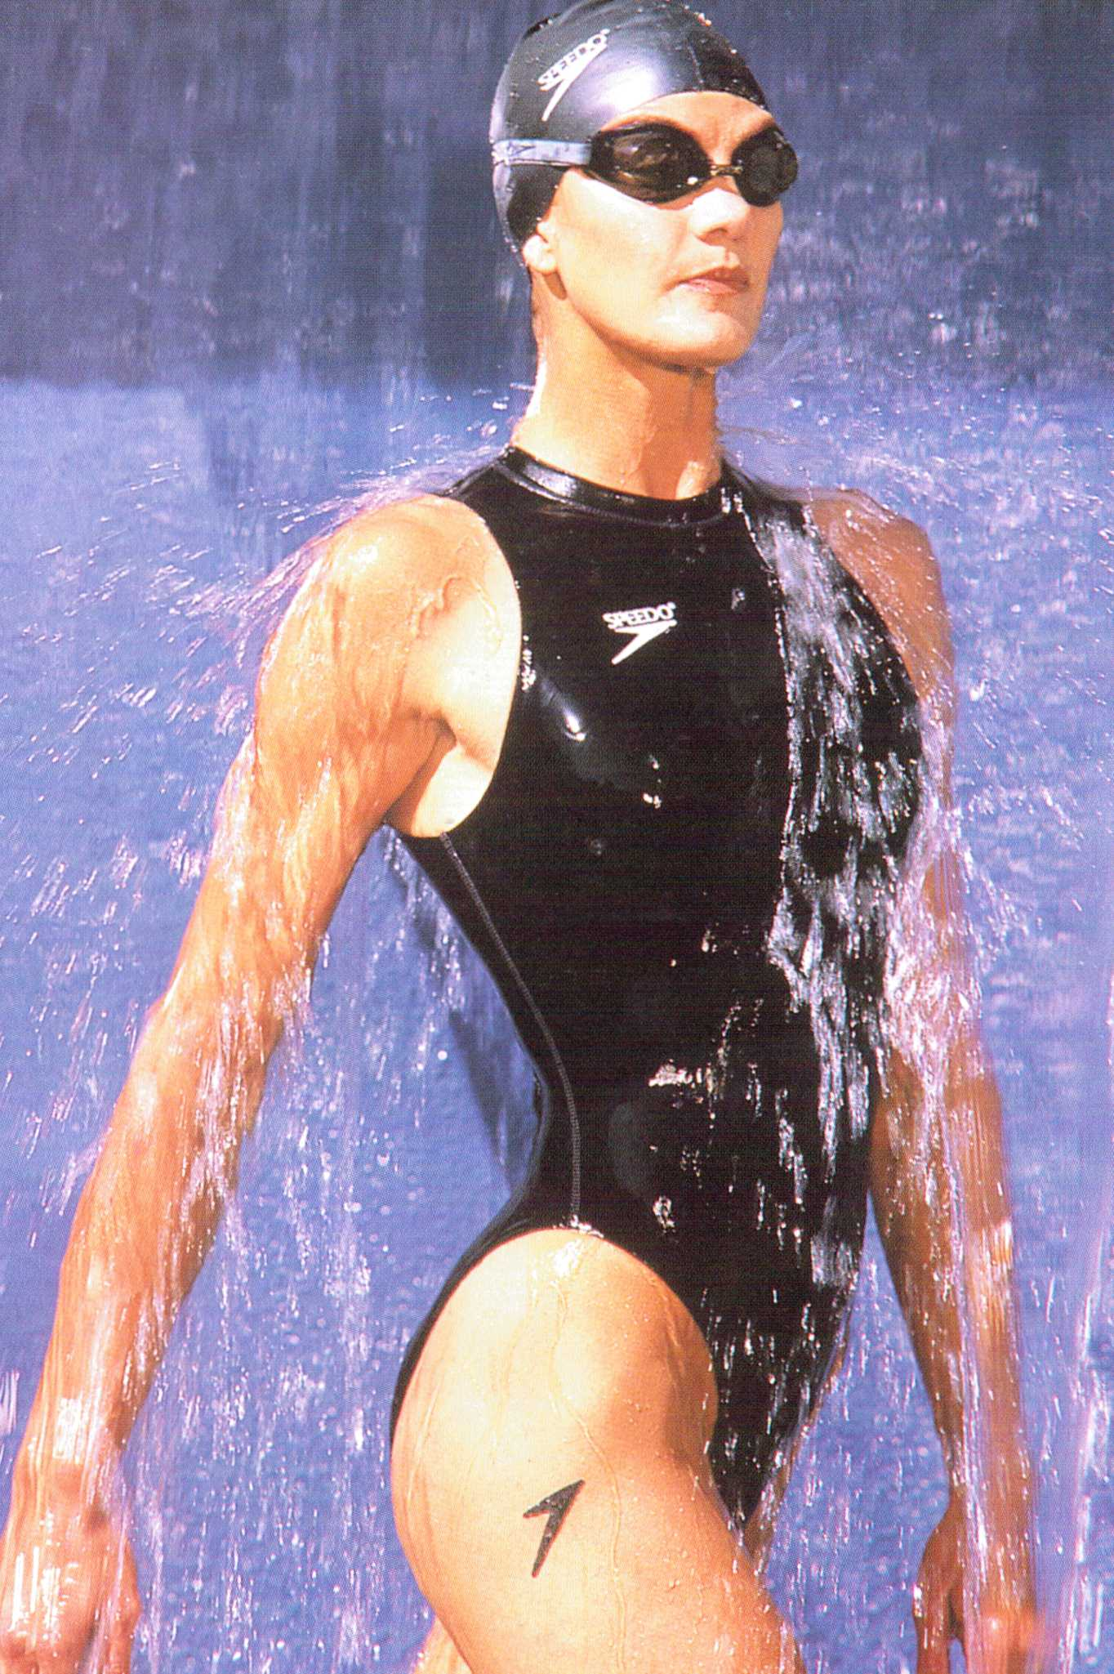
Figure 1: Speedo: ‘S2000’ one piece swimsuit (1998)

The second image shows an Italian fashion photo shoot in 1961, where the designer was evidently inspired by swimwear design.
Figure 2: ‘The Italian Collections, Florence, Queen, March 1961 Norman Parkinson

The effect of of cultural ecologies on fashion expression

The influence of cultural ecologies supports the ‘bubble up’ theory when subcultures adopt an image which is then copied by the ‘high end’ fashion market. The Varsity influenced baseball jacket is a good example of this, seen at Louis Vuitton, Rag and Bone and Timo Weiland (N.Y) Ready to Wear Summer 2012 Collections to retail in time for the 2012 London Olympics. It is also noteworthy that Adidas have commissioned Stella McCartney, a leading British Fashion Designer to design the Team GB apparel and associated Olympic ‘lifestyle’ merchandise. McCartney is associated with celebrity and her designs are both street style inspired and glamorous, featuring white ‘sport deluxe’ separates adorned with gold foil prints, more akin to fashion than sport. This is a clear indication of the symbiosis that exists between fashion and performance sportswear design. Lagerfield, Gaultier, Klein, Galliano, Prada and Koshino have all created collections in the past inspired by performance sportswear styling and fabrication. Many have worked in collaboration with fabric manufacturers to launch a new fibre such as Julien Macdonald who used the antimicrobial fibre Amicor in his Spring/Summer 2000 collection.

There are many European and American ‘new wave’ designers adopting the ‘sport deluxe’ trend which embodies, femininity, coolness, irony, luxury and function as shown in Krizia Robustella’s (Spain) ‘street life’ collection of lustrous ‘tactel’ jogging suits and Katty Xiomara (Portugal) collection of Polyamide, Tencel lurex and silk jersey layered separates.
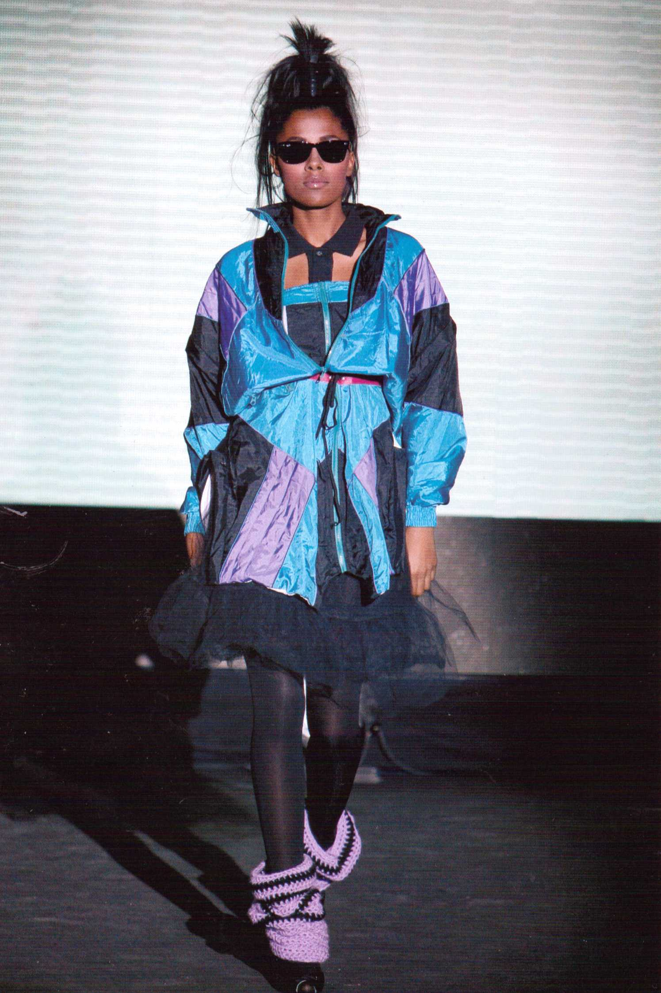
Figure 3: Collection: Street life. Tactel jogging suits.
Designer: Krizia Robustella (2008)

Other lifestyle fashion designers such as CTRL clothing (illustrated) from Helsinki Jeepney (U.S.A.) and Nikita (Iceland); associate their look with the ‘urban style’ of dressing which is influenced by music, humour, multi-functionality and adorned with abstract and dynamic graphics or graffiti prints which make a striking statement. Tee shirts, hoodies, bright coloured jeans and cargos provide a canvas for freestyle graphic art and creativity. This style of graphics flows from hardware to software, with fabrics and textiles being influenced by skateboards and snowboards. Minguet. (2009:93)
Figure 4: Hanoi jacket and
thirdbase T-shirt Designer: Freeman (2008) Monsa.com

Asian and American designers being particularly savvy in computer digital technology are fascinated by the use of smart materials in clothing. Hussein Chalayan’s 2007 collection featured a light display system within its structure so that patterns within the textile could be changed, an idea that was originally trialled in visible safety systems for snowsports jackets. Electronics companies like ‘Phillips’ and ‘Fibretronic’ have enabled sportswear designers to incorporate Ipods and MP3 players into outdoor clothing, which has also now been taken up in ‘street style’ body warmers. Philips Design, Perfect performance. O’ Mahony (2002:81)
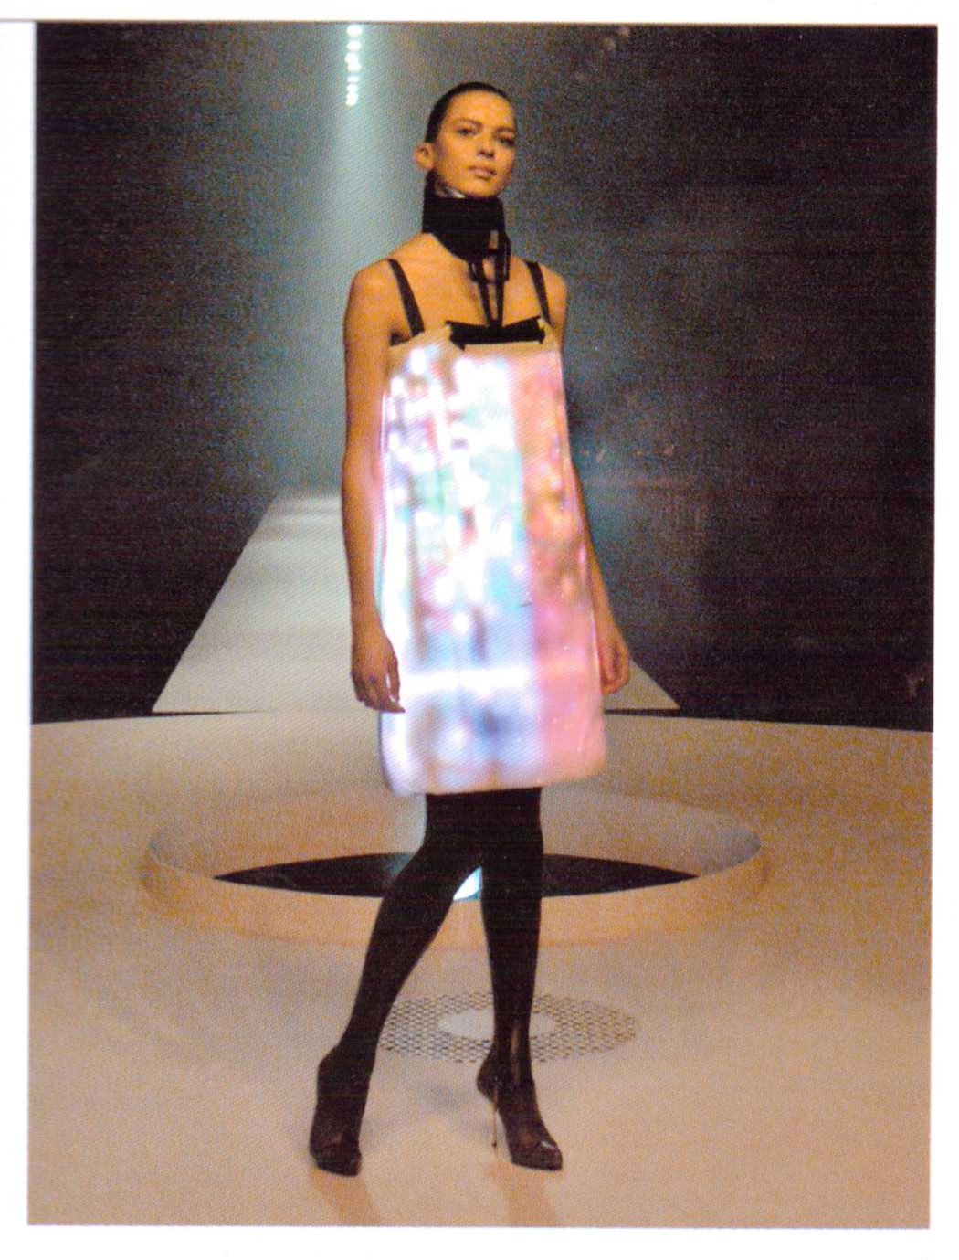
Figure 5: Hussein Chalayan’s A/W 2007 collection features a light display system.

Technology is being used to generate new fabrics and also to make existing fabrics more quickly and efficiently. Computer Aided Design and Computer Aided Manufacture have shortened the lead times for creating or copying a new trend from the catwalk to point of sale in record times. Unfortunately plagiarism from internet sites is a negative part of the advancement in technology whilst unavoidable it also helps to sustain new and positive design innovation.

The influence of performance sportswear on sustainable design
Whilst the Americans and Australians originally created the sports influenced street style clothing to provide comfort in a warm climate, it is clear that this design concept has now been permanently adopted on a global scale and is here to stay. Lifestyle clothing is more than a sustainable type of clothing influenced by global cultures, it has provided democratic attire which has enabled everyone whatever their age, background or gender, to feel comfortable and move with ease, something that was unimaginable to people living a century ago.

The sales that emanate from performance sportswear and street- style clothing are infinite. Link sales are provided in sunglasses, watches, goggles, helmets, hats, gloves, bags, footwear, socks, and ‘Armourwear’ for protection. Most importantly, the whole accessory market is image driven and is just as important as the clothing sector. Image and kudos have also had an effect on safety and protection. Kevlar (Du Pont) helmets are now worn by snowboarders for image as well as safety as design companies like Roxy and Burton have produced stylish designs and complimentary colours to their clothing ranges.
Scope for the future.
The collaboration of these two market sectors has positive implications for stakeholders in the production of fabrics and garments in the future, in terms of reducing costs through economies of scale. Fashion fabrics like denim with Lycra were developed using dirt repelling Teflon coatings by Goretex in 2010 to make them weatherproof and bring street style to the sports arena.
The Schoeller Spinning group (swiss) are now producing a number of aramid- based hybrid fibres……a stretch broken fibre that forms the core with another protective yarn surround. This is used as a backing for aluminized protective suits and cut resistant protective clothing. They have also produced a Merino Wool randomly interspersed with stainless steel yarn for use in antistatic clothing….Less than a decade ago this would not have been possible without reducing or even destroying the performance of one or both functionalities. O’Mahony (2011:356)
Technology in the advancement of synthetics can improve performance fabrics by introducing finishes and enzyme dyes into the fibres that are not harmful surface treatments that cause pollution. The company ‘FibreVisions’ have recently produced thermally insulating, breathable polypropylenes called ‘CoolVisions’ which can be dyed using disperse dyes for the performance sportswear company ‘North Face.’ These fabrics have been used in flannel shirts aimed at the lifestyle clothing market and are chemical and stain resistant and produce cost effective moisture management properties. They are also manufactured using more ‘environmentally friendly’ production methods. Non-woven fabrics or bonded textiles, first developed for medical or protective purposes are being more widely used in both sportswear and fashion, offering non porous, quick drying properties and low cost production. Fabrics can also be moulded into shapes and therefore require less seams which cut down production costs.

The ‘thrill seeking’ and ‘instant gratification’ nature of the youth market will continue to develop more extreme sports and related subcultures and as nanotechnology advances, there will undoubtedly be more applicable end uses and commercial possibilities in the clothing, textile and footwear industry. The eco - friendly message will continue to spread worldwide and awareness of global commitment to improve the economy may mean that discerning consumers will place more demands on the nation and local industry to forge a sustainable future.
The future will undoubtedly be one of smart materials and smart design. O’ Mahony (2011:365)
In all respects there is clearly no turning back.

Bibliography

COLE, D. (2008) Textiles Now. Laurence King Publishing Ltd, London

COLCHESTER, C. (1990) The New Textiles. Trends and Traditions. Thames and Hudson. London

KENNEDY, S, (2010) Vintage swimwear. A history of twentieth century fashions. Carlton books Ltd.

LEE, S. (2005) Fashioning the future. Tomorrow’s wardrobe. Thames and Hudson, London.

MACKENZIE, M. (2010) ISMS. Understanding Fashion. Universe Publishing. U.S.A.

McKENZIE, J. (1997) The best in sportswear design. Batsford. London.

McKENZIE, J. (1998) The best in swimwear design. Batsford. London.

MINGUET. J., M (2009) Urban Fashion Flavor. Monsa.com

O’ MAHONY, M, et al. (2002) SPORTSTECH. Revolutionary Fabrics, Fashion and Design. Thames and Hudson, London

POLHEMUS, T, (1998) DIESEL WORLDWIDE WEAR. Thames and Hudson. London

SMITH, C, et al. (2005) XTREME FASHION. Prestel publishing. New York.

UDALE, J. (2008) Basics Fashion Design 02. Textiles and Fashion. Ava publishing. S.A

O’MAHONY, M. (2011) Designing Future Textiles: New developments in textile structures and surface treatments in Briggs-Goode, A. & Townsend, K. (Eds) Textile Design: Principles, advances and applications, Woodhead Publishing

Journals

RIGBY, D, (1995) Present and Future Markets for Sports- and Leisurewear.David Rigby Associates, Management Consultants, Manchester.U.K

Appendices

Figure 1 Speedo: ‘S2000’ one piece swimsuit
McKENZIE, J, (1998) P.38 The best in swimwear design. Batsford. London

Figure 2 ‘The Italian Collections, Florence, Queen, March 1961 Norman Parkinson Ltd 2011. Courtesy of Norman Parkinson Archive Art Press Publishing Ltd. U.K

Figure 3 Collection: Street life. Tactel jogging suits. Designer: Krizia Robustella (2008)
MINGUET. J., M (2009) P.98 Urban Fashion Flavor. Monsa.com

Figure 4 Hanoi jacket and thirdbase T-shirt Designer: Freeman (2008)
MINGUET. J., M (2009) P.153 Urban Fashion Flavor. Monsa.com

Figure 5 Hussein Chalayan’s A/W 2007 collection features a light display system within its structure so that the patterns within the textile can be changed.
UDALE, J. (2008) P.39 Basics Fashion Design 02. Textiles and Fashion. Ava Publishing. S.A

